1. 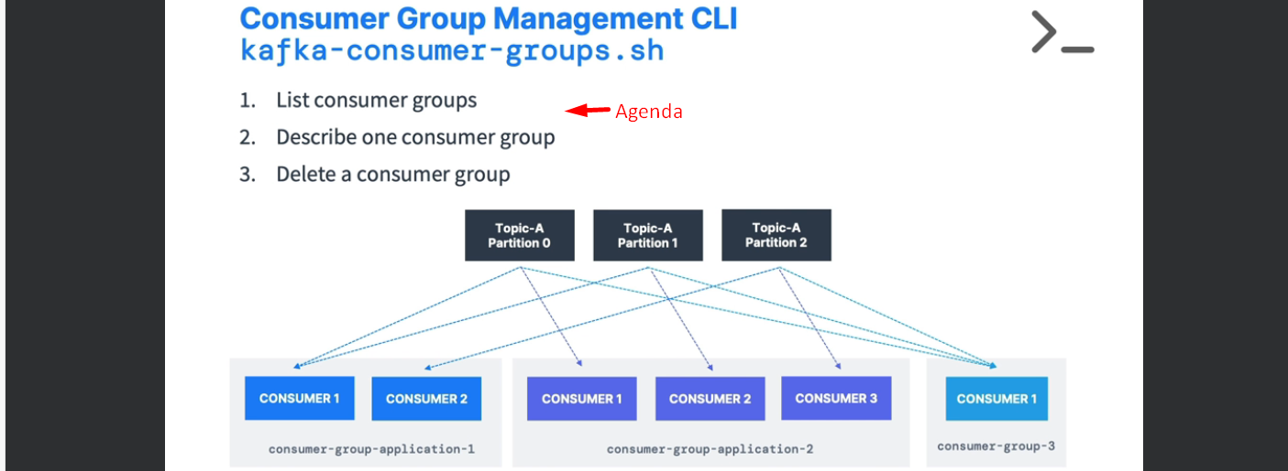
2. Listing Consumer Groups.  
   A close-up of a computer screen

   Description automatically generated
3. Describing the Consumer Group my-second-application.  
     
   A screenshot of a computer

   Description automatically generated
4. A screenshot of a computer

   Description automatically generated  
     
   A white paper with black text

   Description automatically generated
5. Now let’s see one last thing.   
   What if we start a console consumer without a group.   
     
   Let us list all the consumer groups.  
   A red arrow pointing to a white background

   Description automatically generated  
     
   NOTE: Leverage consumer groups we have defined not the ones created automatically.